# Modelling and Solving LP Problems

## Main challenges are:

* formulate LP problem.
* Communicate formulation to computer.
* Use a recognised variable layout.

## Steps

1. Organize the data for the model.
2. Reserve separate cells in the spreadsheet for each decision variable in the model.
3. Create a formula in a cell that corresponds to the objective function.
4. For each constraint, create a formula in a separate cell in the spreadsheet that corresponds to the left-hand side (LHS) of the constraint.

## Goals For Spreadsheet Design

* Communication - communicating information to managers.
* Reliability - The output a spreadsheet is correct and consistent.
* Auditability - A manager should be able to retrace the steps followed to generate the different outputs from the model in order to understand and verify results.
* Modifiability - spreadsheet should be easy to change or enhance in order to meet dynamic user requirements.

## Guidelines

* Organize the data, then build the model around the data
* Do not embed numeric constants in formulas.
* Things which are logically related should be physically related.
* Use formulae that can be copied.
* Column/rows totals should be close to the columns/rows being totalled.
* Use colour, shading, borders and protection to distinguish changeable parameters
* Use text boxes and cell notes to document various elements of the model.

## Make vs. Buy Decisions problem:

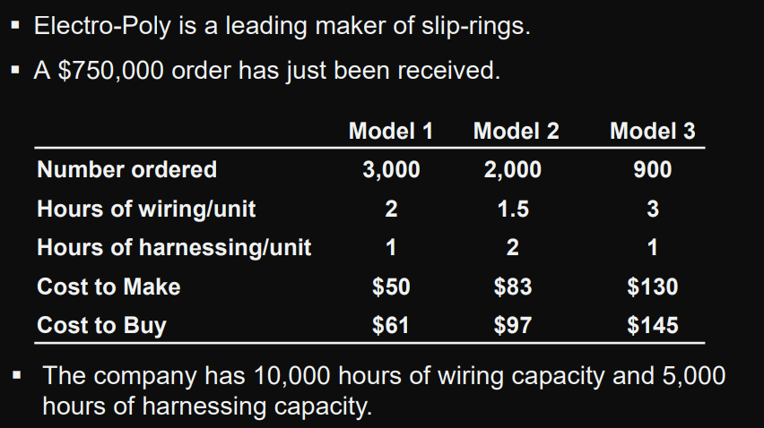

### Defining the Decision Variables

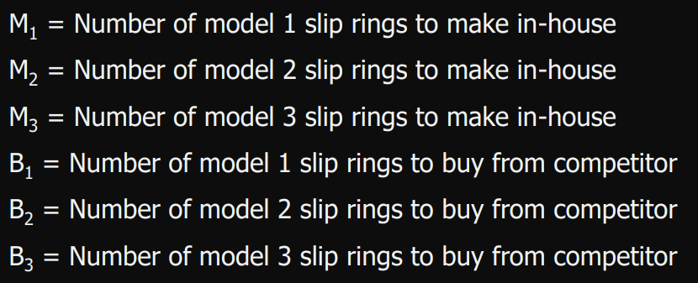

### Defining the Objective Function

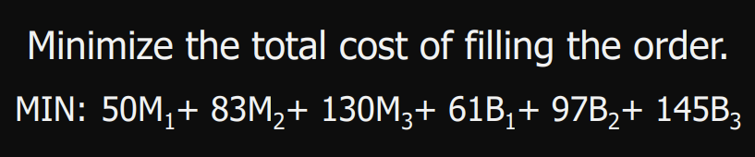

### Defining the Constraints

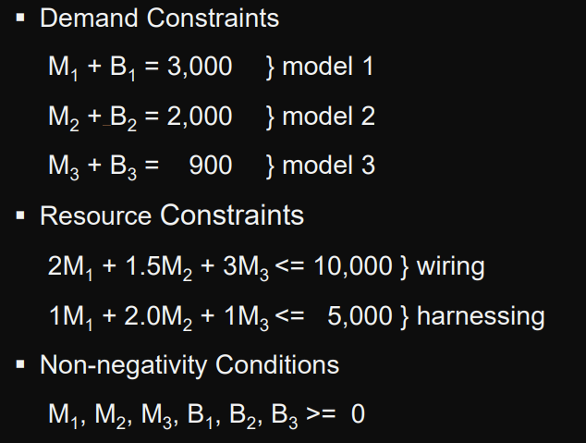

## An Investment Problem:

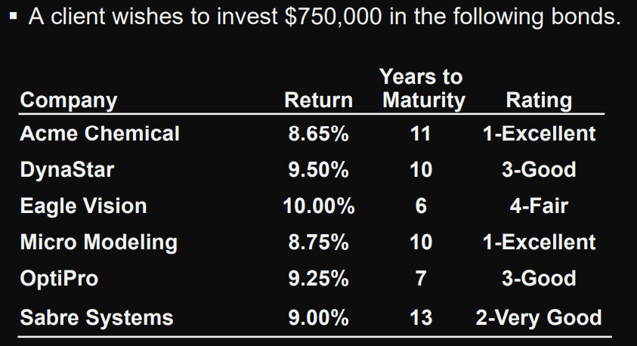

* No more than 25% can be invested in any single company.
* At least 50% should be invested in long-term bonds
* No more than 35% can be invested in DynaStar, Eagle Vision, and OptiPro

## Defining the Decision Variables

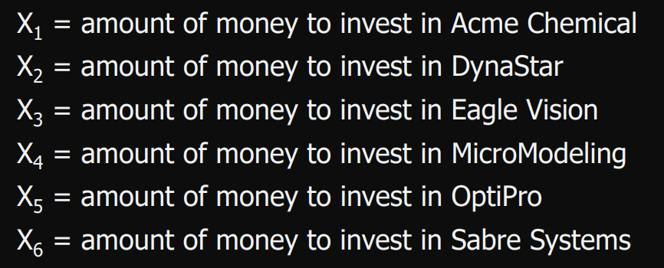

## Defining the Objective Function

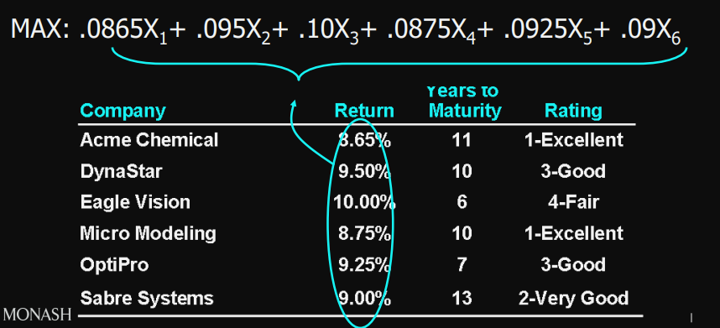

## Defining the Constraints

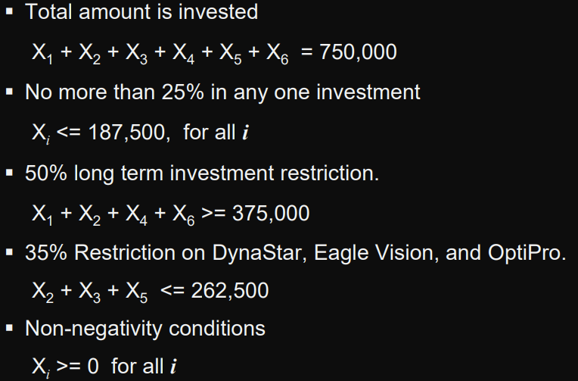

## A Blending Problem:

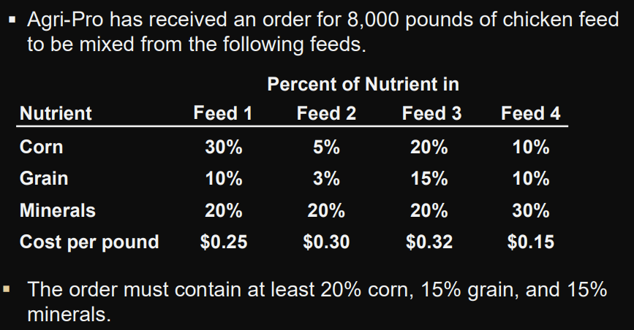

### Defining the Decision Variables

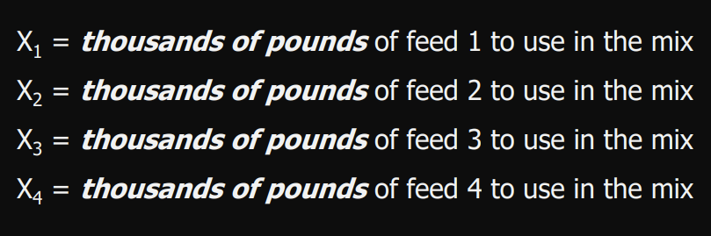

### Defining the Objective Function

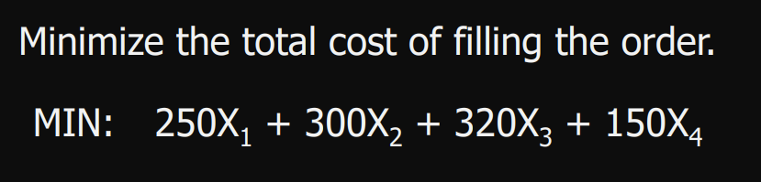

### Defining the Constraints

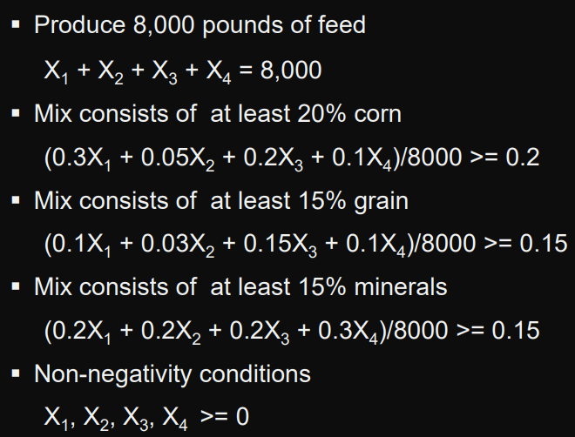

## A Multi-Period Cash Flow Problem:

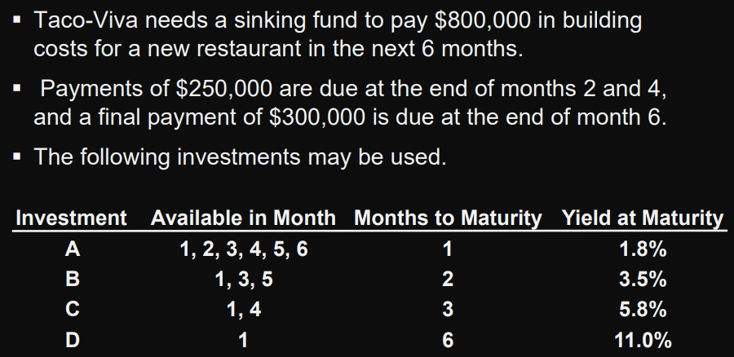

Summary of Possible Cash Flows

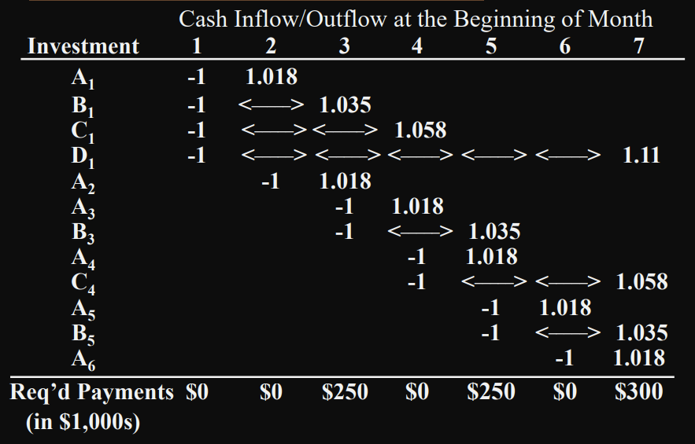

Defining the Decision Variables

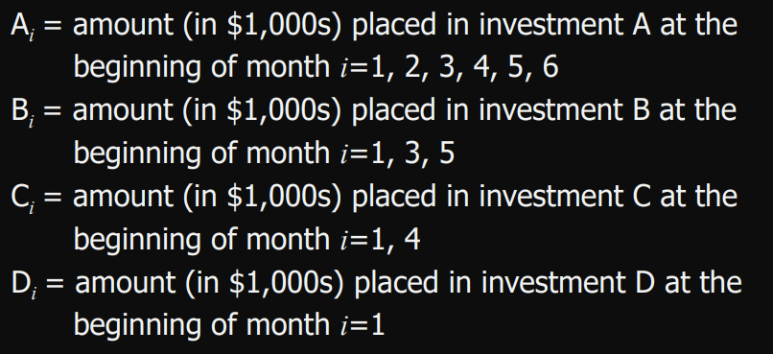

Defining the Objective Function



Defining the Constraints

